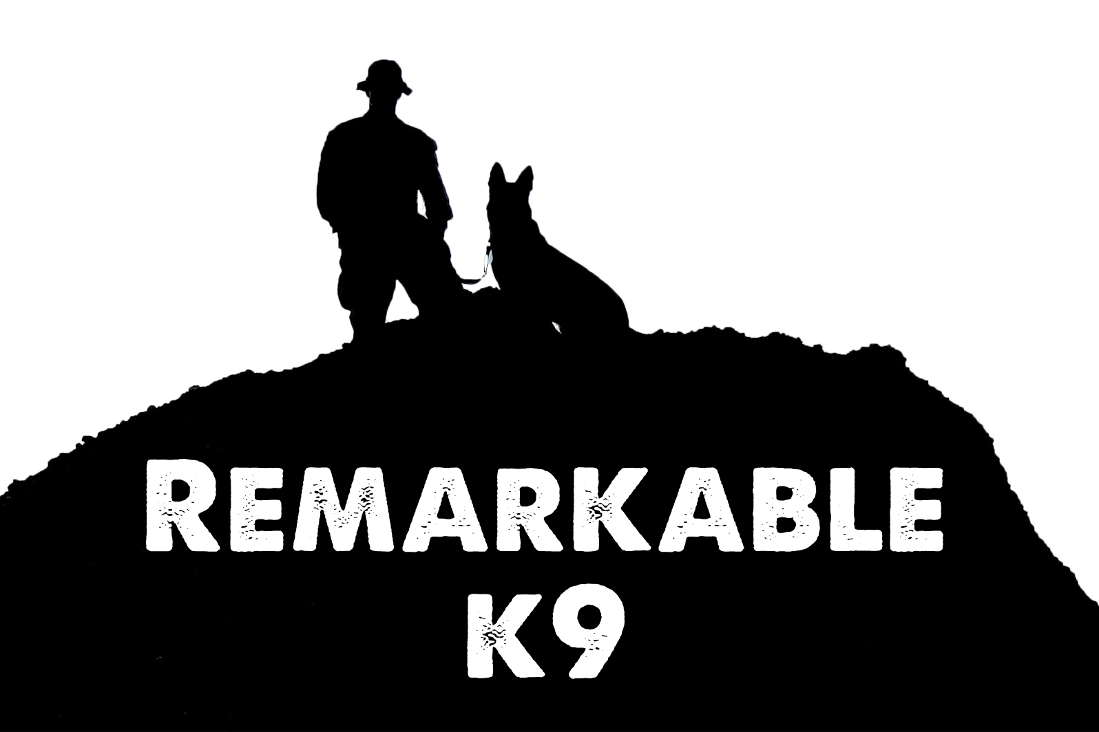

Stop Pulling on the Lead

Walking your canine down the street can be a rewarding experience for both you and your canine. Your canine will have some good one-on-one time with their best friend and might get to see a squirrel or catch a new scent; while you get outside for a nice healthy peaceful walk around the neighborhood. However, sometimes these walks can turn into a tug-of-war with you getting dragged down the street while your canine is choking on the lead. Suddenly, the peaceful walk turns into frustration; but with a little know how, understanding and training, this can be changed into the peaceful walk you envisioned.

First understand your canine wants to explore; they may be reacting to something they have seen or smelled. They are both curious and excited. They want to go investigate whatever has peaked their curiosity. When you pull on the lead to get them under control, they will simply pull back harder. This reaction can be corrected with training and encouragement so they no longer pull on the lead.

Before you go walking, ensure your canine has time to relieve themselves in a designated area. Also, during the initial training try to avoid distraction areas. Seek an area where you can train your canine with little interference. If your canine is pulling and the leash is taut, simply stop and call them back to you. Each time your canine pulls simply stop and call them back again. Soon the canine will learn that a tight lead is not acceptable. You can reinforce this training with treats and praise. Praise should be given for both not pulling and for walking on a loose lead, this will encourage good future behavior. Fortunately, this training works for canines of all ages. Both the puppy and mature canines can master this training. Remember you need to set the pace and direction not your canine.

If your canine has already developed bad pulling habits it can take a little longer to retrain your canine but remember treats and praise go a long way in reinforcing desirable and trained behaviors. Additionally, there are different kinds of collars and leads you can use. A gentle lead goes over and controls their head. When the canine pulls, it redirects their nose and the canine will soon discover they are no longer headed in their desired direction. Collars and martingales focus on securing the canine’s neck while a harness secures their body. All of these devices are useful but each has their own strengths and weaknesses. You should select the one that is comfortable for you. However, be careful not to train and reinforce behaviors that cause your canine to pull. For example, utilizing a harness can strongly reinforce pulling. It allows the dog to use their entire body to pull. Think about a sled dog. They are hooked to the sled in harness type equipment.

Remember this training will not curb your canine’s curiosity, only its behavior. Consider stopping for a moment when appropriate to let your canine investigate a scent so they will enjoy the walk as much as you. Before you know it, your canine will cease pulling on the lead.
When you sign up for your first private session, be sure to inquire about walking a suitcase! A unique leash setup that is gentle and a self-correcting method to stop unwanted pulling.

Remarkable K9 Solutions

